Biohub Protocols: Nanopore Metagenomics (mNGS)

This document contains Oxford Nanopore specific protocols for performing metagenomics sequencing. For details on sample collection and storage, please refer to Section 1 of our mNGS protocol (external link.)

Considerations:
- Consider whether DNA or RNA metagenomics is most appropriate for your application. RNA mNGS can still identify DNA pathogens, (potentially with less sensitivity), but DNA mNGS will always miss RNA viruses.
- Nucleic acid input amounts <1ng to about 20 ng have been tested. Anecdotally, we’ve observed poorer performance with very high input (>100 ng.) If this is the case, dilute your sample.
- For host derived samples (which have lower nucleic acid input than environmental samples or isolates), we recommend using the ONT Rapid PCR Barcoding kit (SQK-RPB114.24).
  - This kit uses the Kit 14 chemistry and is compatible with the 10.4.1 flow cell (FLO-MIN114) on the MinION Mk1B, MinION Mk1C, MinION Mk1D, or GridION.
- It is critical, especially for RNA mNGS, that the samples are high quality with little to no degradation.
- For DNA mNGS, the protocol is a direct adaptation from the manufacturer’s protocol for the Rapid PCR Barcoding kit (SQK-RPB114.24).
- For RNA mNGS, we now (as of late 2025) recommend using the viral RNA portion of ONT’s rapid metagenomics sequencing protocol. (Which is a modified version of the SMART-9N protocol)
- ONT’s protocol suggests loading 50-100 fmol of library, but we have found that loading a higher concentration (100-200 fmol) works better, especially for RNA mNGS

Please reach out to Gowtham Thakku (gowtham.thakku@czbiohub.org) for more details, questions, or explanations.

Workflow:
- Sample Collection, Storage, and Preparation (external link)
- Nucleic Acid Extractions (external link)
- Nucleic Acid Quality Control (QC) (external link)
- ONT Library Preparation
  - DNA library preparation
  - RNA library preparation
- Library QC & Pooling
- Adapter Ligation
- Priming and loading Spoton flow cell
- Concatenating FASTQ files
- Barcode bleeding and mid-read trimming
- Visualization of CZ ID data

Appendix:
- Reagent catalog numbers
- Diagnostic PCR
- Links to additional resources
- Document revision history

4a. ONT Library Preparation - DNA Libraries

This protocol assumes you have extracted and quantified DNA ready for library preparation. For details on DNA extraction and quantification, please refer to Section 2 of our mNGS protocol.

Workflow: DNA Tagmentation, PCR Amplification, SPRI Bead Clean-up, Pooling, Adapter Ligation

Considerations:
- All steps up to setting up of PCR amplification should be done in a pre-PCR space, ideally in a sterile clean hood.
- Reactions should be done in sterile RNAse/ DNAse/ DNA-free tubes.

Protocol: These protocols are an adaptation of the Oxford Nanopore Rapid sequencing DNA PCR Barcoding kit

Step 1. DNA Tagmentation
Reagent | 1 rxn | 0.5 rxn | X rxns
 |  |  | X =
 | vol stock (µL) | vol stock (µL) | vol stock (µL)
DNA sample (1-5 ng total) | 3 | 1.5
Fragmentation Mix (FRM) | 1 | 0.5
Total volume | 4 | 2

Mix by gently flicking the tube, and spin down

Thermocycler (heated lid set to 90˚C):
· 2 min at 30°C
· 2 min at 80°C

Place on ice to cool down

Step 2. PCR Amplification
Reagent | 1 rxn | 0.5 rxn | X rxns
 |  |  | X =
 | vol stock (µL) | vol stock (µL) | vol stock (µL)
Tagmented DNA | 4 | 2
Nuclease-free water | 11 | 5.5
RLB (01-12A, at 1 µM)* | 10 | 5 | Unique to each sample*
LongAmp Taq 2x MM | 25 | 12.5
Total volume | 50 | 25

*RLB primer is at 1 µM in plate format; if shipped in tubes, it’s at 10 µM stock concentration and needs to be diluted 1:10 using nuclease-free water

Mix MM and final rxn. by pipeting up and down. Please in thermocycler with the following conditions:

Thermocycler (lid at 105˚C) | Cycles
95 °C for 3 mins | 1
95 ˚C for 15s | 14-20**
56 ˚C for 15s
65 °C for 6 min*
65˚C for 6 mins | 1
Hold at 10˚C

*Adjust extension time accordingly for different lengths of amplicon

** PCR cycles are dependent on the input DNA. For input <5ng, use 20 cycles.

Step 3. SPRI Bead Clean-up

Perform a SPRI clean-up with a SPRI bead ratio of 0.6x

Allow beads to sit in RT for 30 mins prior. Ensure you have enough 80% ethanol.

1. Add room temperature beads to rxn. Mix well by pipetting up and down 10 times.
2. Incubate for 5 mins at room temperature.
3. Place samples on a magnetic rack, and incubate for 5 mins on the rack.
4. Remove supernatant and add 200uL of 80% EtOH to samples while on the magnetic rack.
5. Incubate at room temperature for 30s and remove the supernatant.
6. Repeat EtOH wash step for a total of 2 times.
7. Air dry the beads for up to 5 mins while on the magnetic rack.
8. Remove tube from magnetic rack. Elute DNA from beads into 10 mM Tris-HCl pH 8.0 with 50
mM NaCl.
9. Pipette mix and incubate for 2 mins at room temperature off the magnetic rack.
10. Place on a magnetic rack until the solution is clear, ~ 5 mins.
11. Aspirate supernatant and transfer to a clean nuclease free PCR tube.

**Checkpoint: Samples can be stored frozen at -20 °C and library prep resumed the next day.

Proceed to Quality Control (QC) and Pooling

4b. ONT Library Preparation - RNA Libraries

For RNA mNGS, we now (as of late 2025) recommend using the viral RNA portion of ONT’s rapid metagenomics sequencing protocol. (Which is a modified version of the SMART-9N protocol.) This protocol requires additional reagents not supplied by the Rapid PCR Barcoding Kit. (See Appendix for reagent catalog numbers.) Key differences between this protocol and the original SMART-9N protocol are:
- Higher concentrations of RLB-9N and RLB-TSO (we have found this makes a significant improvement)
- Choice of reverse transcriptase (RT) enzyme: Maxima (H) Minus instead of SSIV (we have found that this only has a marginal improvement, if at all, so you can use SSIV if that’s more easily available)

Some additional notes:
- We have tried adding ERCC spike-in controls to samples and found that transcript abundance after sequencing correlates well with input. However, there isn’t a straightforward way of doing this analysis since it is not included in the CZ ID long-read pipeline.
- We have also tried using FastSelect for host depletion, but have not observed significant improvement in results.

Step 1. Annealing
Reagent | 1 rxn | 0.5 rxn | X rxns
 |  |  | X =
 | vol stock (µL) | vol stock (µL) | vol stock (µL)
RNA sample | 10 | 4.5
RLB RT primer mix (12 µM) | 1 | 0.5
dNTP mix (10 mM) | 1 | 0.5
Total volume | 12 | 5.5

Mix by gently pipetting up and down

Thermocycler (heated lid set to 80˚C):
· 5 min at 65°C

Snap cool on ice block for 2 min

Step 2. Reverse Transcription
Reagent | 1 rxn | 0.5 rxn | X rxns
 |  |  | X =
 | vol stock (µL) | vol stock (µL) | vol stock (µL)
Annealed RNA | 12 | 6
Maxima H(-) buffer (5X) | 4 | 2
RNase OUT | 1 | 0.5
Maxima H(-) enzyme | 1 | 0.5
TSOmG (12 µM) | 2 | 1
Total volume | 20 | 10 | 20 each

Mix by gently pipetting up and down

Incubate reaction mix as follows (heated lid set to 105˚C):

· 75 min at 42°C
· 5 min at 80°C

Step 3. PCR Amplification
Reagent | 1 rxn | 0.5 rxn | X rxns
 |  |  | X =
 | vol stock (µL) | vol stock (µL) | vol stock (µL)
Tagmented cDNA | 5 | 2.5
Nuclease-free water | 11 | 5.5
RLB (01-24, at 1 µM)* | 10 | 5 | Unique to each sample*
LongAmp Taq 2x MM | 25 | 12.5
Total volume | 51 | 25.5

*RLB primer is at 1 µM in plate format; if shipped in tubes, it’s at 10 µM stock concentration and needs to be diluted 1:10 using nuclease-free water

Mix MM and final rxn. by pipetting up and down. Use the following program for PCR amplification (performed in post-PCR space.)

Thermocycler (lid at 105˚C) | Cycles
95 °C for 45s | 1
95 ˚C for 15s | 30
56 ˚C for 15s
65 °C for 6 min
65˚C for 6 mins | 1
Hold at 4˚C

Step 4. Exonuclease Treatment

Add 1 µL of Thermolabile Exonuclease I per reaction and incubate as follows (heated lid at 105˚C):

· 10 min at 37°C
· 1 min at 80°C

Step 5. SPRI Bead Clean-up

Perform a SPRI clean-up with a SPRI bead ratio of 0.6x

Allow beads to sit in RT for 30 mins prior. Ensure you have enough 80% ethanol.

1. Add room temperature beads to rxn. Mix well by pipetting up and down 10 times.
2. Incubate for 5 mins at room temperature.
3. Place samples on a magnetic rack, and incubate for 5 mins on the rack.
4. Remove supernatant and add 200uL of 80% EtOH to samples while on the magnetic rack.
5. Incubate at room temperature for 30s and remove the supernatant.
6. Repeat EtOH wash step for a total of 2 times.
7. Air dry the beads for up to 5 mins while on the magnetic rack.
8. Remove tube from magnetic rack. Elute DNA from beads into 10 mM Tris-HCl pH 8.0 with 50
mM NaCl.
9. Pipette mix and incubate for 2 mins at room temperature off the magnetic rack.
10. Place on a magnetic rack until the solution is clear, ~ 5 mins.
11. Aspirate supernatant and transfer to a clean nuclease free PCR tube.

**Checkpoint: Samples can be stored frozen at -20 °C and library prep resumed the next day.

Proceed to Quality Control (QC) and Pooling

5. Quality Control (QC) and Pooling

For QC, determine the quality of the finished libraries, pool libraries and quantify the final pooled libraries

Workflow: High sensitivity DNA Qubit, Tapestation/Bioanalyzer/Qiaxcel

Protocol:
See the manufacturer’s protocol for using a capillary electrophoresis quantification system: Tapestation/Bioanalyzer/Fragment Analyzer/Qiaxcel. If a capillary electrophoresis system is unavailable, see Appendix B for a Diagnostic PCR alternative.

- Perform a qubit HS DNA quantification using 1uL of each sample library.
  - Water controls should have substantially less or unquantifiable concentrations than the rest of the samples.

- Assess the sample library sizes by tapestation/bioanalyzer/etc. (this can be done on the final pool rather than each sample individually after you feel confident that you can make consistently sized libraries)
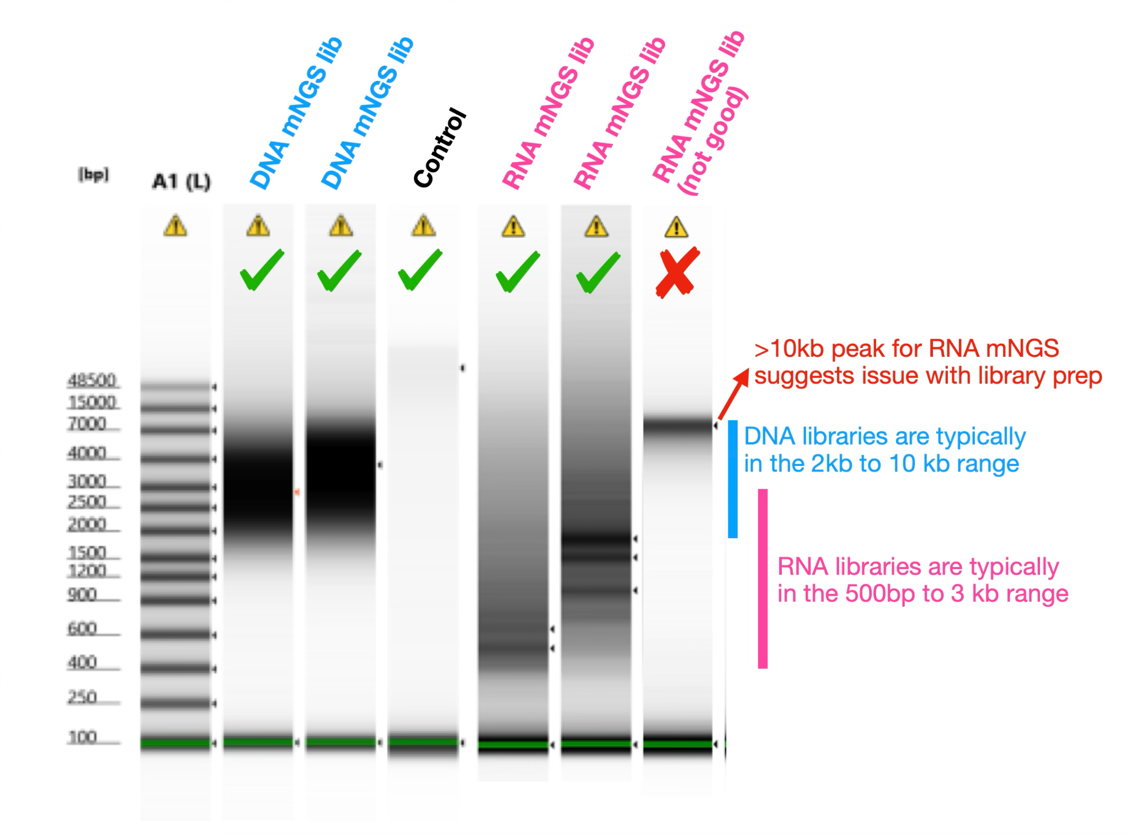
- Pool all barcoded libraries in the desired ratios to a total of 100-200 fmols* in 11 µL of nuclease-free water. Concentration of each sample can be calculated from the Tapestation instrument using the region molarity value, or converting the concentration from DNA Qubit (ng/µL) to fmoles/µL based on the mean library size.
*ONT’s protocol suggests 50-100 fmol, but we have found that loading a higher concentration works better, especially for RNA mNGS.
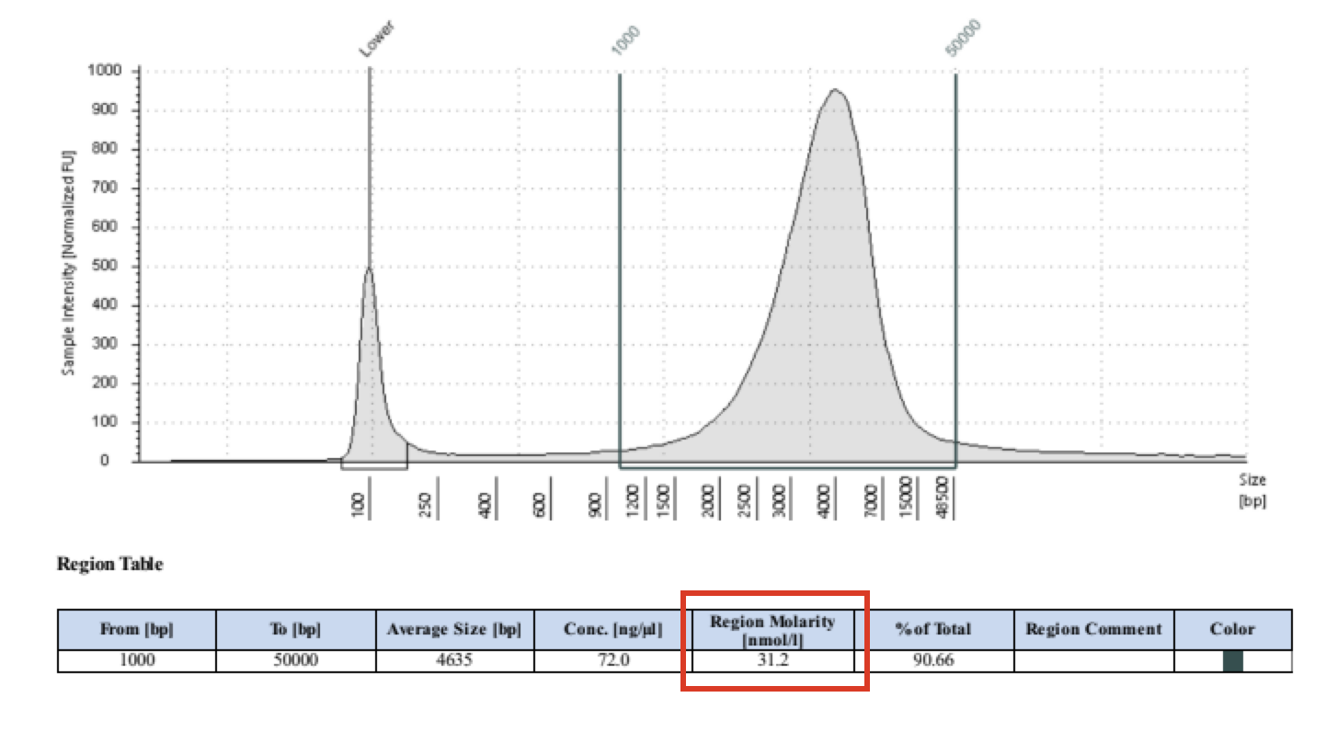

**Checkpoint: Samples can be stored frozen at -20 °C and library prep resumed the next day.

6. Adapter Ligation

This step needs to be performed immediately prior to loading. (Fine to have it sit on ice for ~30 min to an hour)

In a fresh 1.5 ml Eppendorf DNA LoBind tube, mix 3.5 µL Adapter Buffer (ADB) with 1.5 µL Rapid Adapter (RA) for a total of 5 µL of diluted Rapid Adapter.

Add 1 µL diluted adapter to the barcoded DNA, mix gently by pipetting up and down, incubate for 5 min at room temperature.

The prepared library is ready to be loaded into the MinION flow cell. Store the library on ice until ready to load.

7. Priming and loading the MinION flow cell

Follow this protocol from ONT for priming and loading the flow cell

8. Concatenating FASTQ files

Oxford Nanopore sequencing generates output files in time-based batches. By default, MinKNOW typically writes output approximately every hour during an active sequencing run. As a result, each barcode/sample may be associated with multiple FASTQ files. (For example, a 6-hour run may generate ~6 FASTQ files per barcode.) Before downstream analysis (including upload to CZ ID), all FASTQ files corresponding to the same barcode/sample must be concatenated into a single FASTQ file per sample.
Concatenation can be done using standard command-line tools (e.g., cat on Mac/Linux). You can learn more by following CZ ID’s guide on how to concatenate sequence files.

9. Barcode Bleeding and Mid-Read Trimming
Barcode bleeding can occur when samples are pooled, library fragment sizes are short, and a target is present at very high abundance in one sample. Under these conditions, low-level misassignment of reads between barcodes may occur. This is particularly noticeable in low biomass samples or negative controls. Although typically low frequency, barcode bleeding can introduce background signals and complicate interpretation.
To mitigate this issue, reads containing barcode or adapter sequences in the middle of the read can be removed prior to downstream analysis. A web-based tool to perform mid-read barcode trimming is available here.
This application runs directly in a web browser without requiring installation. For larger files (>250 MB), running the tool locally is recommended for improved performance. The tool removes reads containing internal barcode or adapter sequences, and the cleaned FASTQ file can then be used for downstream analysis and CZ ID upload.

10. Visualization of CZ ID Data
At this time, the CZ ID ONT pipeline does not include a built-in heatmap visualization. To generate heatmaps from CZ ID ONT results, use the ONT Heatmap Generator. This web-based application runs directly in a browser and does not require installation. It allows users to generate heatmaps from CZ ID outputs (sample taxon reports) and is designed specifically for ONT long-read metagenomic data. The tool enables visualization of relative abundance of taxa across samples, much like the Illumina heatmap functionality on CZ ID.

Appendix

Appendix A: Catalog links and numbers
See linked Google Sheet for catalog numbers and notes

Appendix B: Diagnostic PCR

- If you are unable to use a high sensitivity capillary electrophoresis system, you can perform a diagnostic PCR instead as a proxy for the overall library size. Do note that this method tends to slightly overestimate the size of the library.

- Take 1 uL of the individual libraries or final pool and perform a standard PCR reaction for 20 cycles using one of the following primers:

- Barcoding PCR primer (RLB-01 to RLB-24):
5' - ATCGCCTACCGTGAC - barcode - CGTTTTTCGTGCGCCGCTTC - 3'
OR
- End adapter portion of barcoding PCR primer:
5' - ATCGCCTACCGTGAC - 3'
OR
- Front adapter portion of barcoding PCR primer (RLB-PCR from SMART-9N publication):
5’ - TTTTTCGTGCGCCGCTTCA - 3’
- For each sample or pool, setup the amplification reaction as follows:

Component | Volume (µL)
LongAmp Master Mix (2x) | 25
Nuclease-free Water | 23.5
Primer (10µM) | 0.5
DNA Template | 1
Total Volume | 50

- Use the following cycling conditions:

Thermocycler (lid at 105˚C) | Cycles
95 °C for 45s | 1
95 ˚C for 15s | 20
X ˚C for 15s*
65 °C for 5 min
65˚C for 10 mins | 1
Hold at 10˚C | ∞

*X depends on which primer is being used

X = 59˚C if using Barcoding PCR primer (RLB-01 to RLB-24)

X = 53˚C if using End adapter portion of barcoding PCR primer

X = 56˚C if using Front adapter portion of barcoding PCR primer

- Run PCR amplified product on a 1% gel with a 1kb ladder control to visualize. The volumes used will depend on the gel electrophoresis system being used.

Appendix C: Additional Resources

CZ ID help center
https://help.czid.org
- Upload ONT data
- Concatenate files
- Analyze Nanopore Data
- Edit Metadata

ONT resources
- ONT chemistry overview: Chemistry Technical Document | Oxford Nanopore Technologies
- MinKNOW intro and overview: MinKNOW Technical Document | Oxford Nanopore Technologies
- MinKNOW quick guide: MinKNOW | Oxford Nanopore Technologies
- Basecalling and data analysis: Data analysis | Oxford Nanopore Technologies
- Barcode + adapter sequences: Chemistry Technical Document | Oxford Nanopore Technologies (search “RLB” to quickly find the right section)
- R10 flow cell loading: Rapid sequencing DNA - PCR Barcoding Kit 24 V14 (SQK-RPB114.24) (RPB_9191_v114_revD_16Oct2024) | Oxford Nanopore Technologies
- Post-run flow cell wash: Flow Cell Wash Kit (EXP-WSH004 or EXP-WSH004-XL) (WFC_9120_v1_revQ_08Dec2020) | Oxford Nanopore Technologies
- Mk1b computer requirements: MinION Mk1B IT requirements | Oxford Nanopore Technologies
- Rapid metagenomic sequencing for surveillance of bacterial, fungal and viral pathogens using SQK-RPB114.24: Rapid metagenomic sequencing for surveillance of bacterial, fungal and viral pathogens using SQK-RPB114.24

Papers
- Gauthier, et al. JID 2024: Validation of an Automated, End-to-End Metagenomic Sequencing Assay for Agnostic Detection of Respiratory Viruses
- Simmonds, et al. BioRxiv 2024: CZ ID: a cloud-based, no-code platform enabling advanced long read metagenomic analysis

Appendix D: Document revision history

Workflow | Date | Description of Change
Diagnostic PCR | 1/16/2025 | Added in protocol
Diagnostic PCR | 6/16/2025 | Added detail for gel visualization step
Updated RNA mNGS protocol | 1/8/2026 | Updated to follow ONT’s version of SMART-9N
Appendix | 3/2/2026 | Additional resources
mNGS workflow | 3/2/2026 | Addition of steps after sequencing: concatenation of FASTQs, mid-read filtering, ONT heatmap generation

